Tenda MW5-Another mobile phone wants to manage my MW5. What should I do?

Method 1: Provide my account to my family. And they can manage my MW5 by Tenda WiFi App.

Method 2:
Step 1: Download Tenda WiFi App by another mobile phone. Tap “Login”.

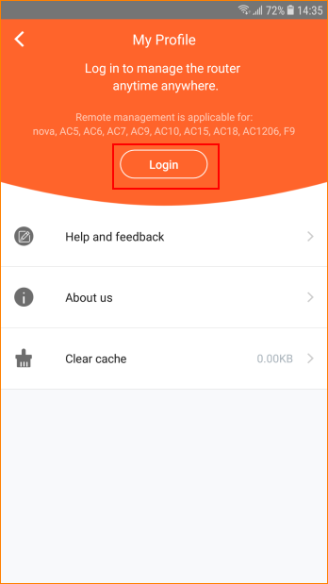

Note:
For IOS system, please download from App Store.
For Android system, please download from Play Store.

Step 2: If you have configured Google Email, Facebook, Twitter in mobile phone, you can tap the icon to login faster.

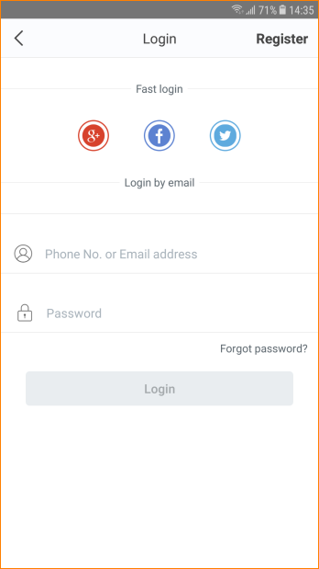

Step 3: If you want to register by email, tap “Register”, enter Email address and Password.

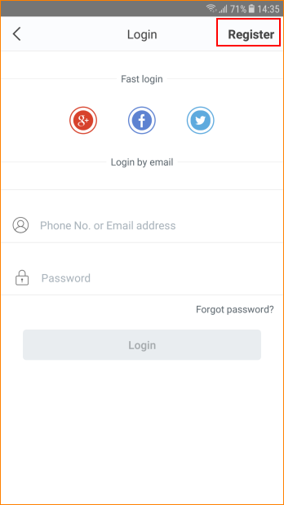

Step 4: Open my Tenda WiFi App, tap “Settings”> “Account Authorization”.

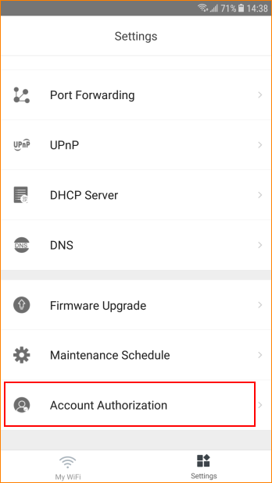

Step 5: Tap “Add an account’.

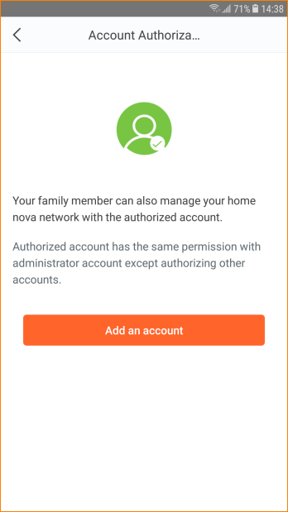
Step 6: Enter the registered account. Tap “OK”.

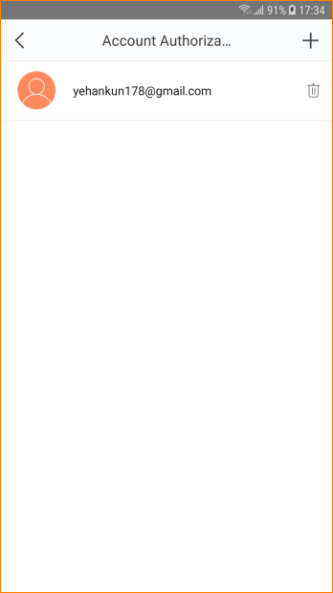

Note:
1. Totally can add no more than three accounts to manage a same MW5.
2. Authorized account does not support “Account Authorization” function.

